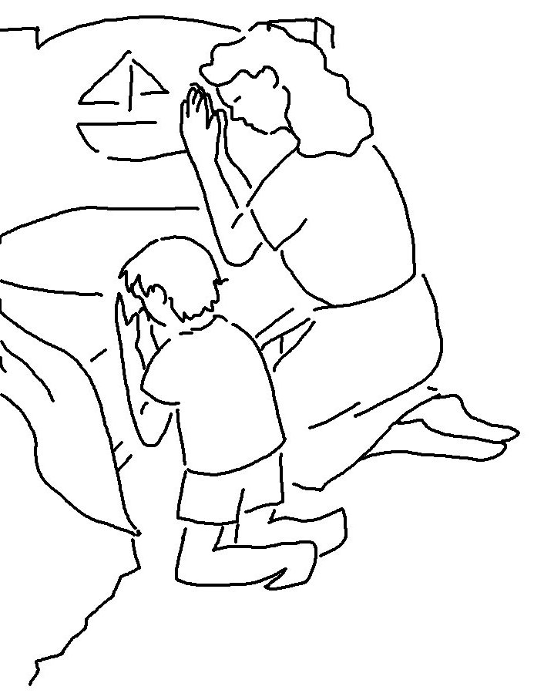
Lord, what do You want me to do?
Acts 9:6 _{NKJV}

